System Requirements Statement (SRS) –

BikeLeLo

**Table of contents:**

**1.** **Introduction 4**

**2.** **Functional Requirements 5**

2.1 End-User Module 6

2.2 Showroom Module 10

2.3 **a**dmin Module 16

2.4 Use Case Diagram 19

THIS DOCUMENT CONTAINS 21 NUMBERED PAGES

# Introduction

This document explains the system requirements and scope for developing BikeLeLo System.

BikeLeLo System could divide the three main modules, Admin Module, Showroom Module and User Module.

This document describes the system requirement of the Account part.

# Functional Requirements

The Account part of BikeLeLo System has three modules which are divided into 26 processes described below.

|  |  |  |
| --- | --- | --- |
| **No** | **BRS requirement ID** | **Description** |
| **2.1** | **End-User Module** | |
| **2.1.1** | **F1** | **Account Creation Process** |
| **2.1.2** | **F2** | **Login Process** |
| **2.1.3** | **F3** | **Forgot Password Process** |
| **2.1.4** | **F4** | **Change Password Process** |
| **2.1.5** | **F5** | **Update Account Information** |
| **2.1.6** | **F6** | **Location Selection Process** |
| **2.1.7** | **F7** | **Search for Bike Process** |
| **2.1.8** | **F8** | **Compare Bikes Process** |
| **2.1.9** | **F9** | **Booking Bike** |
| **2.1.10** | **F10** | **Cancel Booking Process** |
| **2.2** | **Showroom Module** | |
| **2.2.1** | **F11** | **Account Creation Process** |
| **2.2.2** | **F12** | **Login Process** |
| **2.2.3** | **F13** | **Forgot Password Process** |
| **2.2.4** | **F14** | **Change Password Process** |
| **2.2.5** | **F15** | **Update Account Process** |
| **2.2.6** | **F16** | **Publish Bike Catalogue** |
| **2.2.7** | **F17** | **Update Bike Catalogue** |
| **2.2.8** | **F18** | **Track Booking Confirmation** |
| **2.2.9** | **F19** | **Cancellation Request** |
| **2.3 Admin Module** | | |
| **2.3.1** | **F21** | **Login Process** |
| **2.3.2** | **F22** | **Forgot Password Process** |
| **2.3.3** | **F23** | **Change Password Process** |
| **2.3.4** | **F24** | **Update Account Process** |
| **2.3.5** | **F25** | **System Management** |
| **2.3.6** | **F26** | **Reports Generation** |

## End-User Module

* End-user is the main user of the system who wants to buy the bike.
* They are also able to search and compare various bikes.

### Account Creation Process

* BikeLeLo System will have two types of users i.e. Registered and Non-Registered.
* Non-Registered users can only search and compare the bikes.
* BikeLeLo System compels users to create an account to book bikes. So, BikeLeLo System should provide the function which allows users to create new accounts.
* When user creates new account, the function demands following information :

1. Login information
2. Contact Details

* **The Login information:**

The Login information consists of some items described as below.

1. UserID (Same as E-mail ID)
2. Password
3. First Name
4. Last Name
5. E-mail address
6. Date of Birth
   * All items are compulsory.
   * UserID

* The UserID should be unique. If the UserID matches with previous UserID then the provided UserID should not be registered.
  + Password
* The Password has constraints which makes the Password consists of more than or equal 8 and less than or equal 12 characters including characters described below.

1. Numeric figure (at least one)
2. Capital alphabet (A-Z)(at least one)
3. Small alphabet (a-z)(at least one)
4. Special character (#, $, %, &, @) (at least one)

* The Password is masked by dummy characters. The re-entering Password is demanded.
* The Password must be encrypted in the BikeLeLo System.
* Contact Details
  + The Contact Detail consists of items described as below.
* Permanent Address
* Contact Number
  + All items are compulsory.
  + Permanent Address
* Permanent Address should be filled.
* The state should be selected from options.
* Security Question information
* The Security Question information is needed when a user loses their Password. This information consists of two items described below.
* Selected Question
* Answer
* Hint (Not similar as Answer)
  + All items are compulsory.
  + Some questions which are difficult to answer for anyone else are prepared in advance. E.g. which colour do you like most?
  + A question should be selected from options by the user, and the Answer and hint is registered by the user.

### Login Process

* BikeLeLo System always compels registered users to authenticate before booking any bike.
* The user authentication demands UserID and Password. The UserID and the Password should be checked in two ways.
  + First, the UserID and the Password should exist and be corrected.
* If the UserID and the Password are not equal to what the user has registered, the user authentication cannot proceed.
  + Second, UserID should be available.
* The Administrator can decide whether the UserID is available or suspended – Refer to the SRS of the Admin part.
* If a user is rejected, user authentication is not provided for system user.
* The user account should live for so long as the duration decided by Admin.
* Only when the two checks are successfully completed, user be placed on a respected page.
* The “Side Menu” provides the items described as below.

1. A trigger to Home
2. A trigger to update Account
3. A trigger to Change Password
4. A trigger to Search New Bikes
5. A trigger to Search New Scooter
6. A trigger to Search New Electric Bike
7. A trigger to Upload Review
8. A trigger to logout

### Forgot Password Process

* When a system user loses their Password, the recovery method should be provided by the BikeLeLo system.

The recovery method is described below.

* + First, a registered user enters their UserID for BikeLeLo System.
  + Next, the BikeLeLo System demands the Answer which has been registered while creating the account.
  + Only when the Answer is correct, user get the form to reset the new password.
  + The new password should consist of more than or equal 8 and less than or equal 12 characters including at least a numeric figure, a capital alphabet, a small alphabet, and a special character.
  + If the Answer is incorrect, the correct Answer is demanded from the user again for 3 times after that hint will be shown.

### Change Password Process

* When a user wants to change their Password, the function will be available in BikeLeLo System.
* Therefore, BikeLeLo System provides this function only when the user is logged in.
* The function demands the current password and the new password.
  + Of course, the new password should consist of more than or equal 8 and less than or equal 12 characters including at least a numeric figure, a capital alphabet, a small alphabet, and a special character.
  + The current password and the new password are masked by using dummy characters.
  + The new password is demanded to enter twice to avoid a typing error.
  + The new password will not be the same as the current password.
* Only when the current password is correct, user can change their Password.
* When the current password is changed into a new password, BikeLeLo System compels the user to login again.

### Update Account Information

* BikeLeLo System should provide the function which makes the account updated for users.
* The information the user could update is described below.
* Login information
* User information
* Security Question Information
* The Login information

The updatable items as described below.

* Password
  + All items are compulsory, but updating is optional if there are any corrections required.
* The User information

The updatable items as described below.

* First Name
* Last Name
* User Phone No
  + All items are compulsory, but updating is optional if there are any corrections required.
* The Security Question information

The updatable items as described below.

* Selected Question
* Answer
* Hint
  + All items are compulsory, but updating is optional if there are any corrections required.

### 2.1.6 Location Selection Process

* Search conditions are described as below.
* City

### Bike Searching Process

* Search conditions are described as below.
* Bike category

### Compare Bikes Process

* Compare bike requirements as described below.
* Bike category
* Price
* Bike name
* Bike Specifications
* Photos
* Users can compare two bikes at an instance.

### Booking Bike

* This function enables registered users to book bikes.
* Booking confirmation details
* Payment details.

### Cancel Booking Process

This system allows cancellation of booking with following terms:

1. 10% deduction in booking amount within 2 Days of booking.
2. After 2 days, 25% deduction in booking amount till 5th Day of booking.
3. After 5 days, 50% deduction in booking amount till 7th Day of booking.
4. After 7 days, no refund will be issued on cancellation of booking.

#### Showroom Module

### 2.2.1 Account Creation Process

* In the BikeLeLo System, showrooms need to be registered for publishing their bikes.
* Once an account request is approved by the BikeLeLo Admin, then only the showroom can publish their bikes on the portal.
* While Showroom’s account creation, the function demands following information:
* Login information
  + - * Contact Details
      * Security Question Information
* Payment information.
* The Login information
* The Login information consists of some items described as below.
  + - * UserID
      * Password
      * Showroom Name
* Showroom’s address
  + All items are compulsory.
  + UserID
* The UserID should be unique. If the UserID matches with previous UserID then the provided UserID should not be registered.
  + Password
* The Password has constraints which makes the Password consist of more than or equal 8 and less than or equal 12 characters including characters described as below.

1. Numeric figure (at least one)

2. Capital alphabet (A-Z)(at least one)

3. Small alphabet (a-z)(at least one)

4. Special character (#, $, %, &, @) (at least one)

* The Password is masked by dummy characters. The re-entering Password is demanded.
* The Password must be encrypted in the BikeLeLo System.
  + Showroom Name

The showroom Name must be entitled with the brand name. Ex: Gajanan Suzuki

(Where, Gajanan will be name of showroom and Suzuki will be brand name)

* + Showroom Address

The showroom must provide a complete address with some landmark and pin code details.

* Contact Details
  + The Contact Detail consists of items described as below.
    - * Service Email Address
      * Contact Phone No.
  + All items are compulsory.
* The Security Question information
* The Security Question information is needed when the showroom admin loses their Password. This information consists of three items described below.
* Selected Question
* Answer
* Hint (Not similar as Answer)
  + All items are compulsory.
  + Some questions which are difficult to answer for anyone else are prepared in advance. E.g. which colour do you like most?
  + A question should be selected from options by the user, and the Answer and hint is registered by the showroom.

### Login Process

* BikeLeLo System always compels showrooms to authenticate before publishing any bikes or access their dashboard.
* The showroom authentication demands UserID and Password. The UserID and the Password should be checked in two ways.
  + First, the UserID and the Password should exist and be corrected.
* If the UserID and the Password are not equal to what the showroom has registered, the showroom authentication cannot proceed.
  + Second, UserID should be available.
* The Administrator of BikeLeLo can decide whether the UserID is available or suspended – Refer to the SRS of the Admin part.
* If a user is rejected, user authentication is not provided for system users.
* The showroom account should be alive for so long as the duration decided by Admin.
* Only when the two checks are successfully completed, the showroom can be placed on a respected page.
* The “Side Menu” provides the items described as below.

1. A trigger to Home
2. A trigger to update Account
3. A trigger to Change Password
4. A trigger to View Profile
5. A trigger to Publish Bikes for sale
6. A trigger to Update Bikes Information
7. A trigger to Delete Bikes
8. A trigger to Booking History
9. A trigger to Logout

### Forgot Password Process

* When a showroom loses their Password, the recovery method should be provided by the BikeLeLo system.

The recovery method is described below.

* + First, the showroom enters their UserID for BikeLeLo System.
  + Next, BikeLeLo System demands the Answer which has been registered since when the Account was created.
  + Only when the Answer is correct, the showroom admin gets the form to reset the new password.
  + The new password should consist of more than or equal 8 and less than or equal 12 characters including at least a numeric figure, a capital alphabet, a small alphabet, and a special character.
  + If the Answer is incorrect, the correct Answer is demanded from the showroom again for 3 times after that hint will be shown.

### Change Password Process

* When the showroom wants to change their Password, the function will be available in BikeLeLo System.
* Therefore, BikeLeLo System provides this function only when the showroom is logged in.
* The function demands the current password and the new password.
  + Of course, the new password should consist of more than or equal 8 and less than or equal 12 characters including at least a numeric figure, a capital alphabet, a small alphabet, and a special character.
  + The current password and the new password are masked by using dummy characters.
  + The new password is demanded to enter twice to avoid a typing error.
  + The new password will not be the same as the current password.
* Only when the current password is correct, can the showroom change their Password.
* When the current password is changed into a new password, BikeLeLo System compels showroom to login again.

### Update Account Process

* BikeLeLo System should provide the function which makes the account updated for showrooms.
* The information showroom could update is described below.
  + - * Login information
      * User(Showroom) information
      * Security Question Information
* The Login information
* The updatable items as described below.
* Password
  + All items are compulsory, but updating is optional.
* The User information
* The updatable items as described below.
* Showroom Phone No
* Showroom’s Address
* Service Email Address
  + All items are compulsory, but updating is optional.
* The Security Question information
* The updatable items as described below.
* Selected Question
* Answer
* Hint
  + All items are compulsory, but updating is optional.

#### Publish Bike Catalogue

* Showroom can submit bike catalogue including following details:
* Bike Name
* Bike Specification
* Ex-Showroom Price
* On-Road Price (All Tax included)
* Bike Images
* Colour variant Available
* Bike Summary
* About Bike

#### Update Bike Catalogue

* Showroom can update the available bike catalogue information. Following are the fields which are updatable:
* Ex-Showroom Price
* On-Road Price (All Tax included)
* Bike Images
* Colour variant Available

**2.2.8 Track Booking Confirmation**

* + Showroom will be notified about the booking for the specific bike with provided details once booking is confirmed by the user.
* Bike Name
* Selected Bike Variant
* User Details
* Payment Details

**2.2.9 Cancellation Request**

* Showroom will be notified about every cancelled booking request by the user.
* Showroom will initiate a refund with the user based on the provided terms and conditions.

#### Admin Module

* + Administratorshould be responsible for following activities**,**

### Login Process

* BikeLeLo System always compels Admin to authenticate before access to the portal.
* The user authentication demands UserID and Password. The UserID and the Password should be checked in the following way.
  + The UserID and the Password should exist and be correct.
* If the UserID and the Password are not equal to what the user has registered, the user authentication cannot proceed.
* Only when the above checks are successfully completed, users can be placed on a respected page.
* The “Admin Home” provides the items described as below.
* A trigger to Home
* A trigger to update Account
* A trigger to Change Password
* A trigger to Pending request verification
* A trigger to generate reports
* A trigger to Delete user account, suspend showroom account
* A trigger to Logout

### Forgot Password Process

* When Admin loses their Password, the recovery method should be provided by the BikeLeLo system. The recovery method is described below.
  + First, Admin enters their UserID for BikeLeLo System.
  + Next, the BikeLeLo System demands the Answer which has been registered while creating the account.
  + Only when the Answer is correct, users get the form to reset a new password.
  + The new password should consist of more than or equal 8 and less than or equal 12 characters including at least a numeric figure, a capital alphabet, a small alphabet, and a special character.

### Change Password Process

* When Admin wants to change their Password, the function will be available in BikeLeLo System.
* Therefore, BikeLeLo System provides this function only when Admin is logged in.
* The function demands the current password and the new password.
  + Of course, the new password should consist of more than or equal 8 and less than or equal 12 characters including at least a numeric figure, a capital alphabet, a small alphabet, and a special character.
  + The current password and the new password are masked by using dummy characters.
  + The new password is demanded to enter twice to avoid a typing error.
  + The new password will not be the same as the current password.
* Only when the current password is correct, users can change their Password.
* When the current password is changed into a new password, BikeLeLo System compels the user to login again.

### Update Account Process

* BikeLeLo System should provide the function which makes the account updated for Admin.
* The information Admin could update is described below.

1. Login information
2. User information

* The Login information

The updatable items as described below.

1. First Name
2. Last Name
3. E-mail address
   * All items are compulsory, but updating is optional.

* The User information

The updatable items as described below.

1. User Phone No
2. Permanent address
   * All items are compulsory, but updating is optional.

#### System Management

* Admin should able to manage all the accounts with following activities:
* Approve registration request for showrooms.
* Reject registration request for showrooms.
* Monitor all Transactions.
* Admin will be able to watch Users, Showrooms and Bike wise revenue reports.
* All types of reports generation.
* Suspend or disable user accounts.
* Admin can check and monitor the data of any user if required.
* Admin can take any necessary action for any reports and suggestions submitted.
  + 1. **Reports Generation**
* Admin should able to generate all the accounts with following activities:
* Admin should be able to see all the records from any users.
* Daily and weekly periodic reports of sales can be generated by Adm.

#### 2.4 Use Case Diagram

**Admin:**

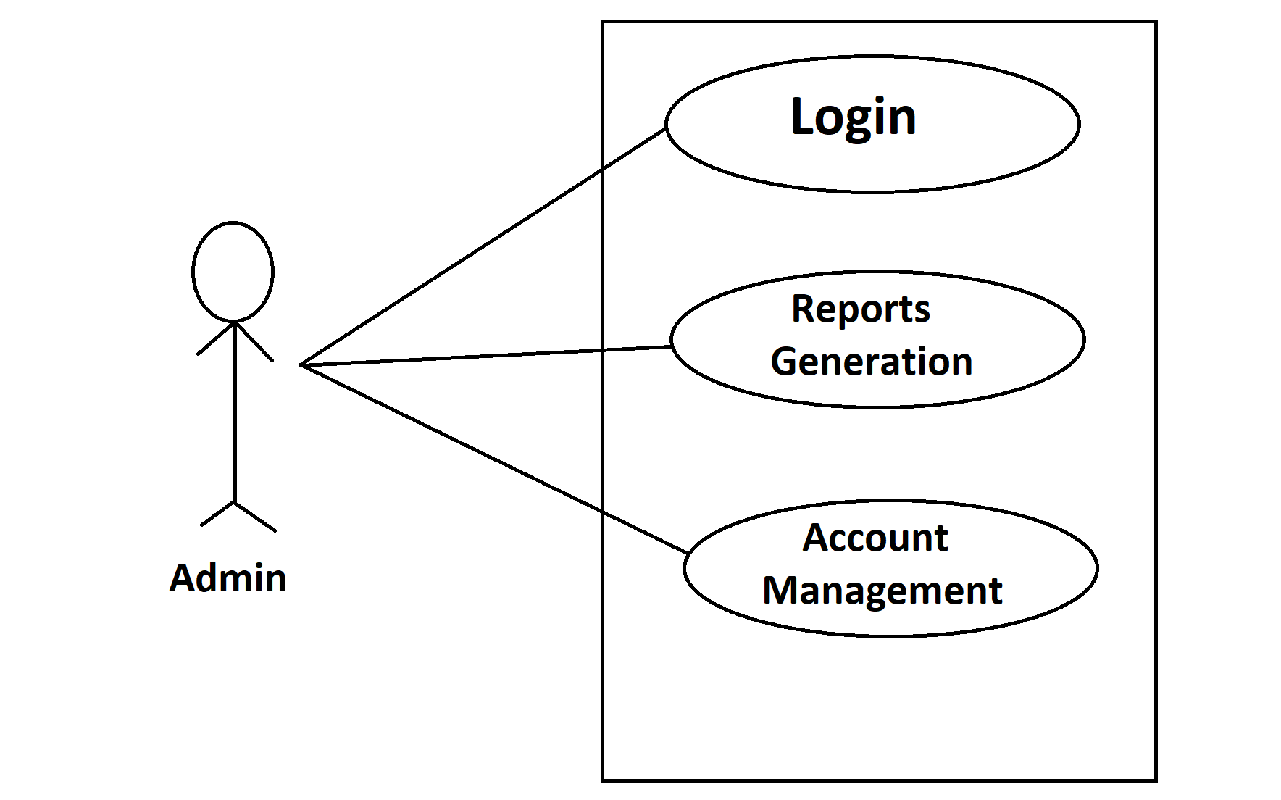

*Fig. Use case diagram for admin*

* In the Admin use case diagram Admin is the Actor.
* Admin can handle following use cases:
* Login
* Reports Generation
* Account Management

**Showroom:**

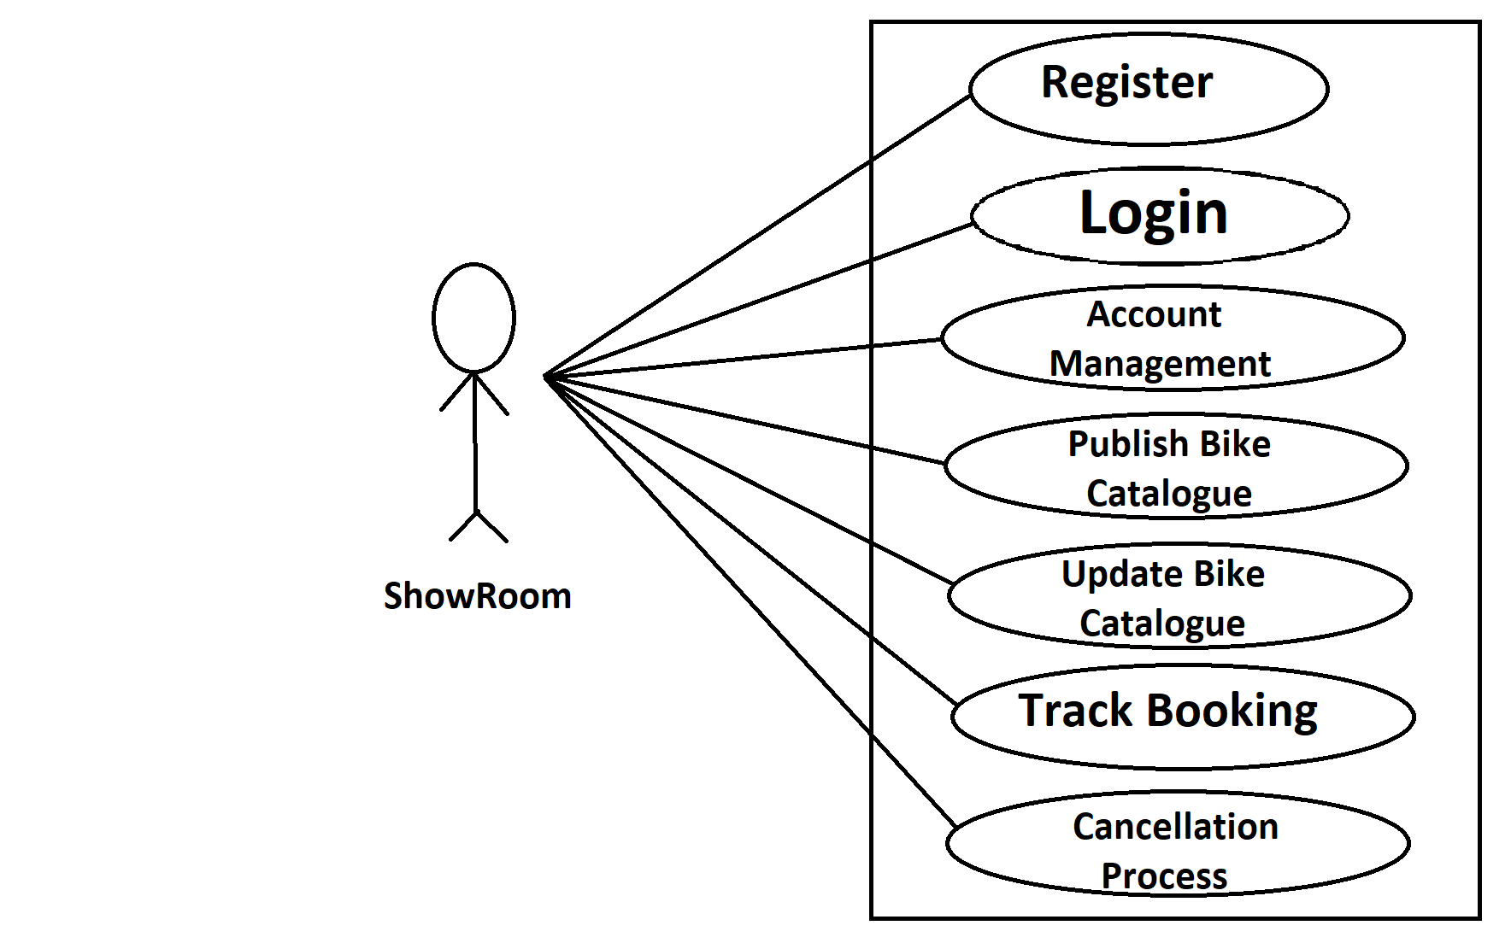

*Fig. Use case diagram for Showroom*

* In the showroom use case diagram the showroom is the Actor.
* showroom can handle following use cases:
* Register
* Login
* Account Management
* Publish Bike Catalogue
* Update Bike Catalogue
* Track Booking
* Cancellation Process

**End-Users:**

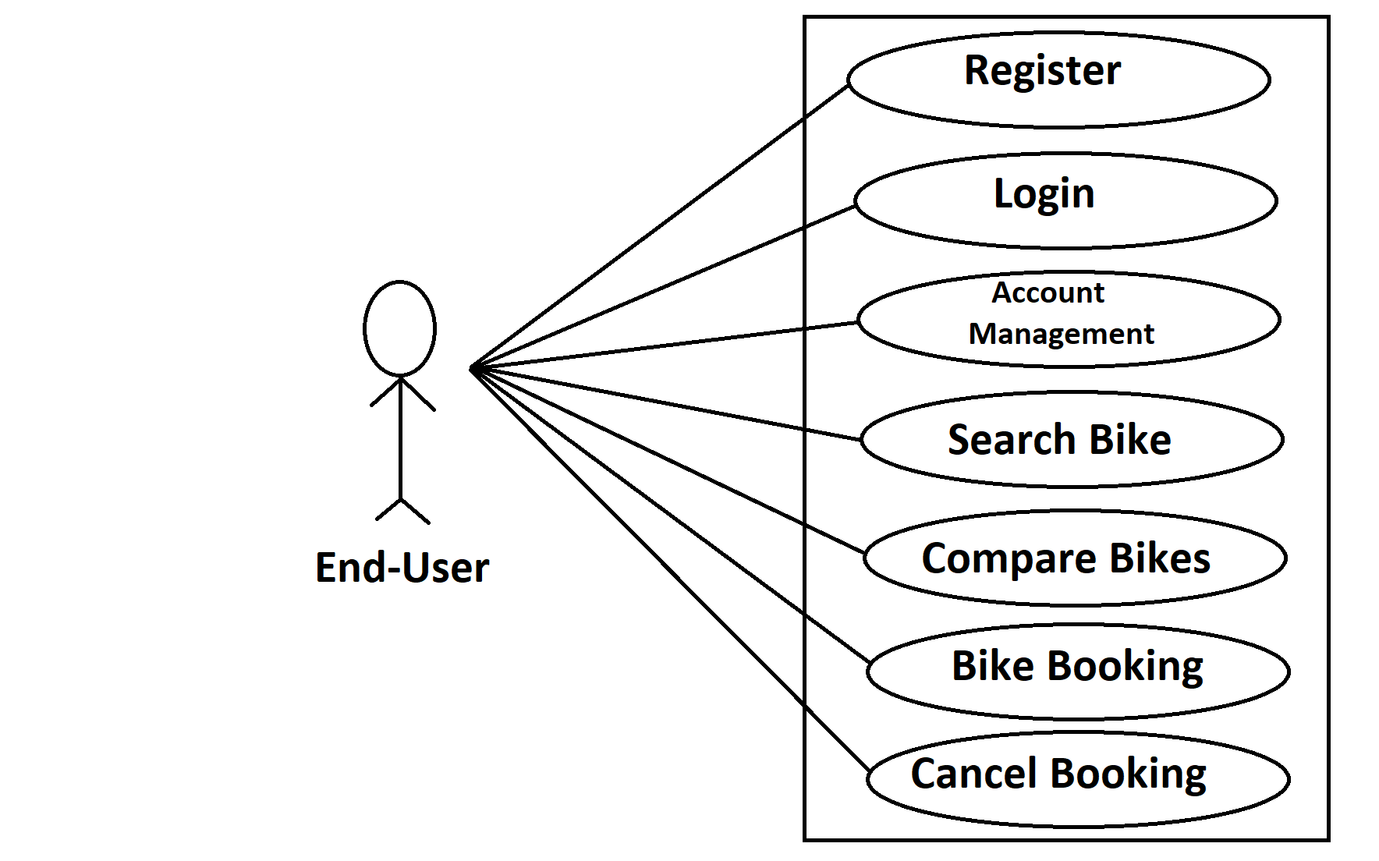

*Fig. Use case diagram for End-Users*

* In End-Users use case diagram End-User is the Actor.
* End-User can handle following use cases:
* Register
* Login
* Account Management
* Search Bike
* Compare Bikes
* Bike Booking
* Cancel Booking